**Application**

Refer to the Air Quality data described previously, and the analyses we have done with Ozone as the response variable, and the five explanatory variables (including the two engineered features).

1. Use PPR to model the relationship between Ozone and all five explanatories (you don’t

need to use the scale() function in the formula). Use max.terms=5. Also use the gcv.spline smoothing method as shown in the example.

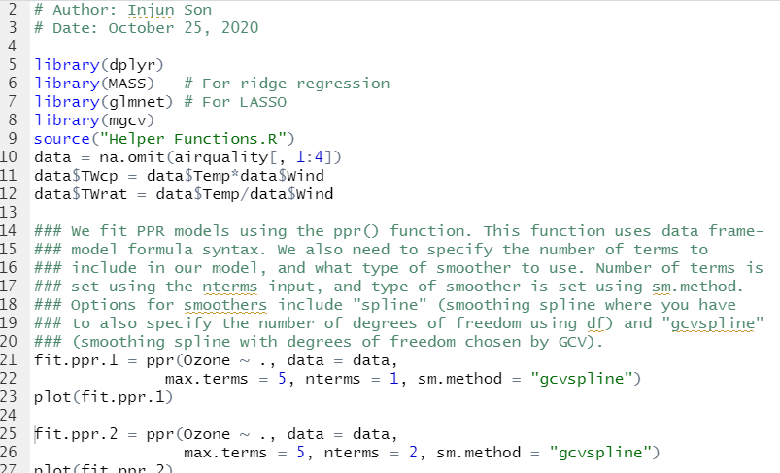

(a) Specify nterms=1.

i. **Show the plot** of the spline for the selected projection

ii. Report the training SSE from the summary

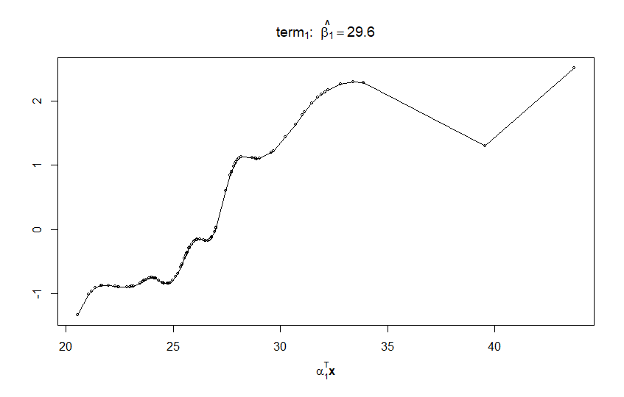

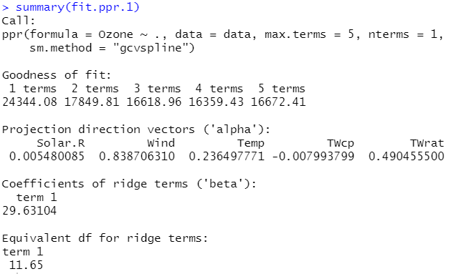

(b) Repeat with nterms=2.

i. **Show the plot** of the spline for the selected projection

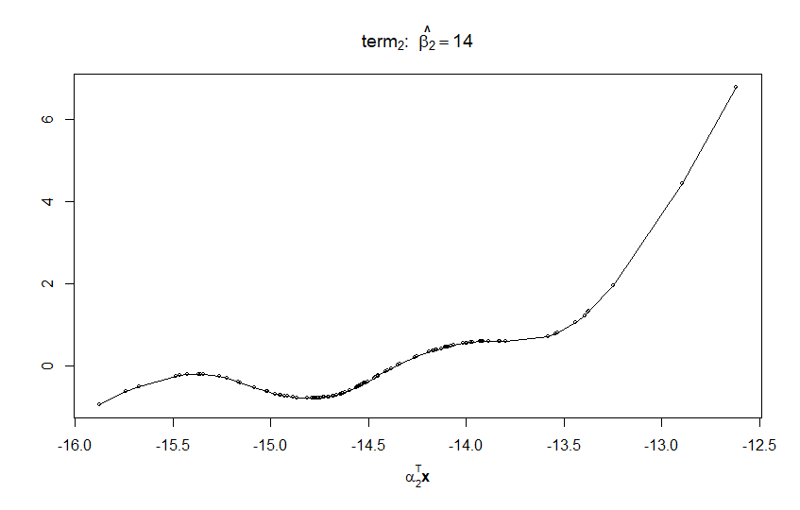

ii. Report the training SSE from the summary

